Test Case: tc001_SPX_Dev5_Crear_Requisicion_Spot_Tipo_Cobro_CC
Step 1 - Enter username and password and click to button Enter : Credentials Entered
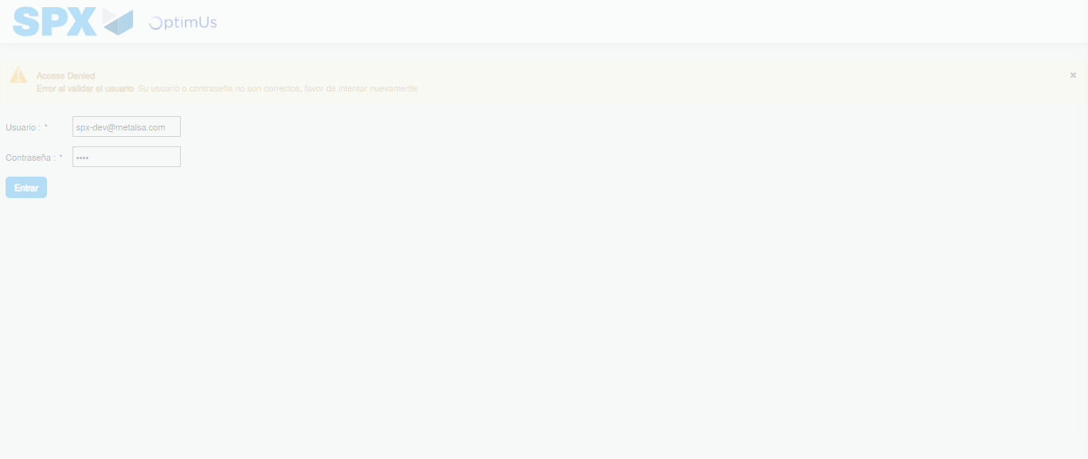Image file-name: QC_Testing-tc001_SPX_Dev5_Crear_Requisicion_Spot_Tipo_Cobro_CC-1782255508946

Step 2 - Select to UEN and Access to Spot Buy Requisitions : UEN Correctly selected and Correct access
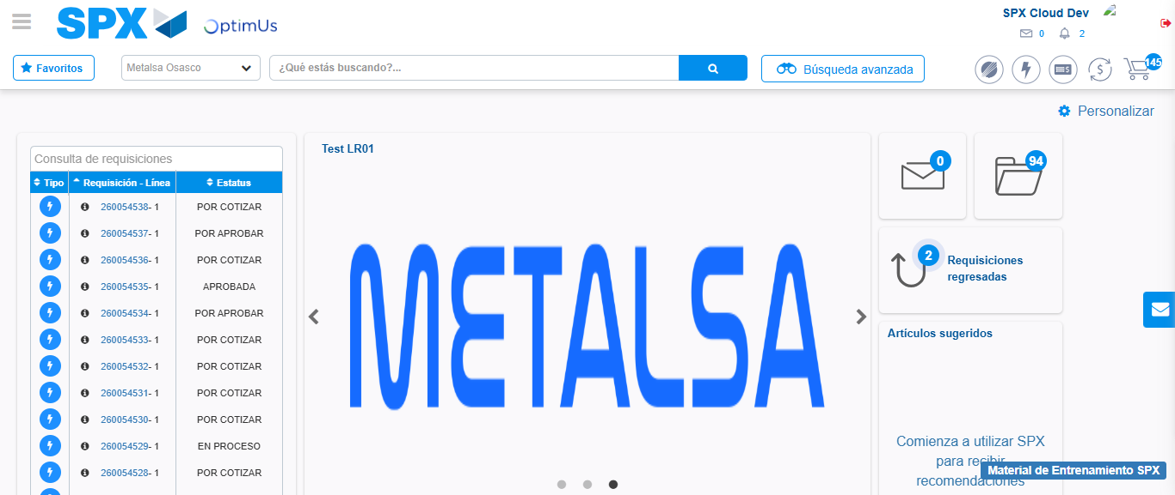Image file-name: QC_Testing-tc001_SPX_Dev5_Crear_Requisicion_Spot_Tipo_Cobro_CC-1782255590665

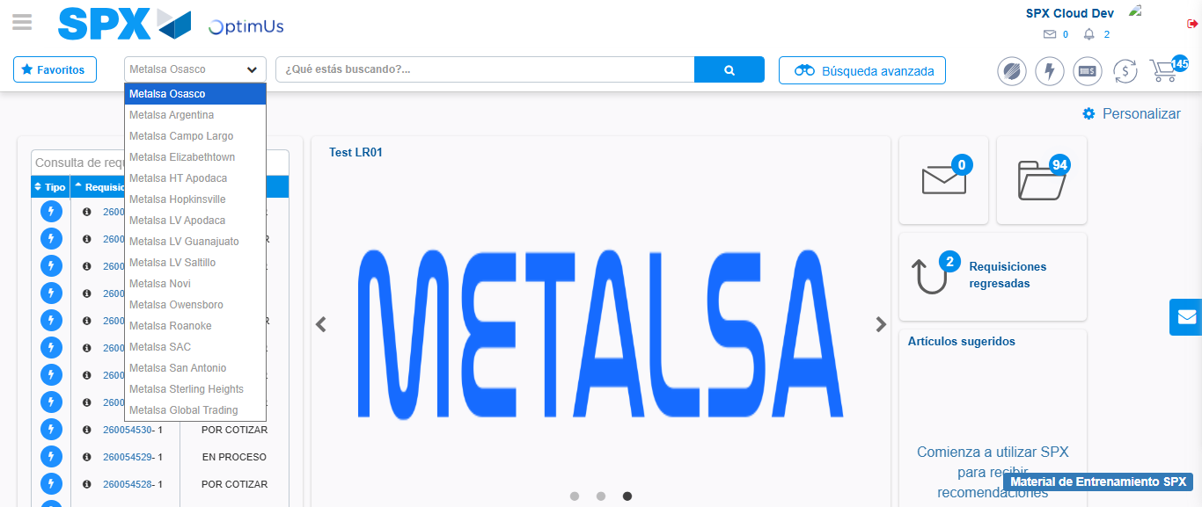Image file-name: QC_Testing-tc001_SPX_Dev5_Crear_Requisicion_Spot_Tipo_Cobro_CC-1782255593450

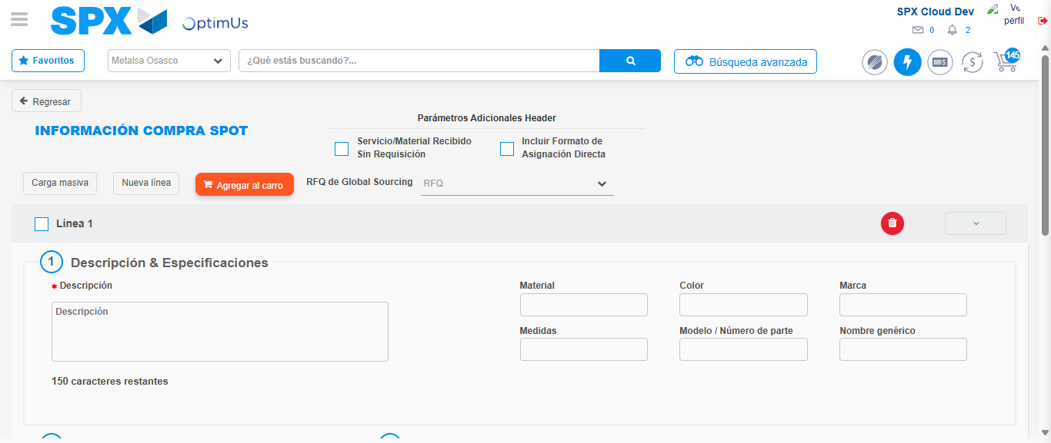Image file-name: QC_Testing-tc001_SPX_Dev5_Crear_Requisicion_Spot_Tipo_Cobro_CC-1782255600749

Step 3 - Data Capture Spot Buy Requisition : Data captured correctly
Image file-name: QC_Testing-tc001_SPX_Dev5_Crear_Requisicion_Spot_Tipo_Cobro_CC-1782255601065

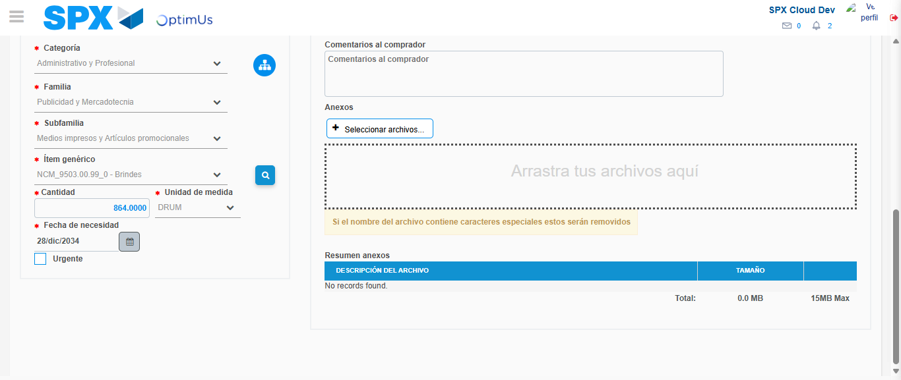Image file-name: QC_Testing-tc001_SPX_Dev5_Crear_Requisicion_Spot_Tipo_Cobro_CC-1782255613848

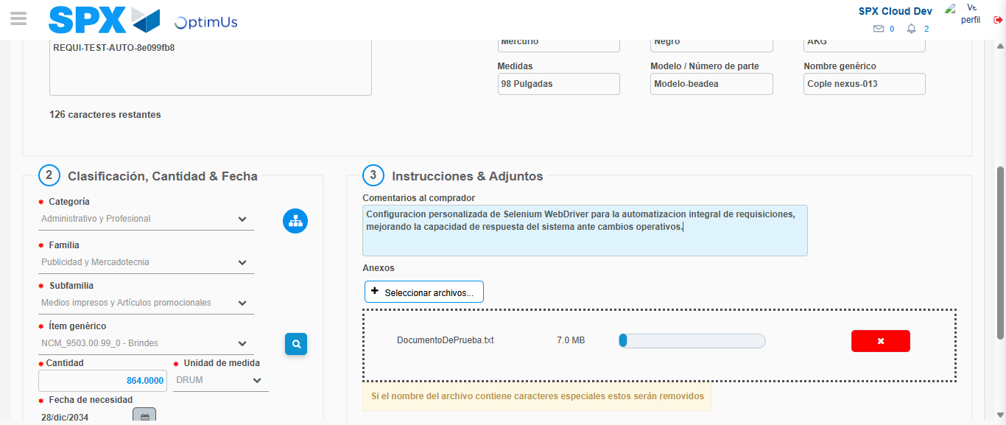Image file-name: QC_Testing-tc001_SPX_Dev5_Crear_Requisicion_Spot_Tipo_Cobro_CC-1782255614854

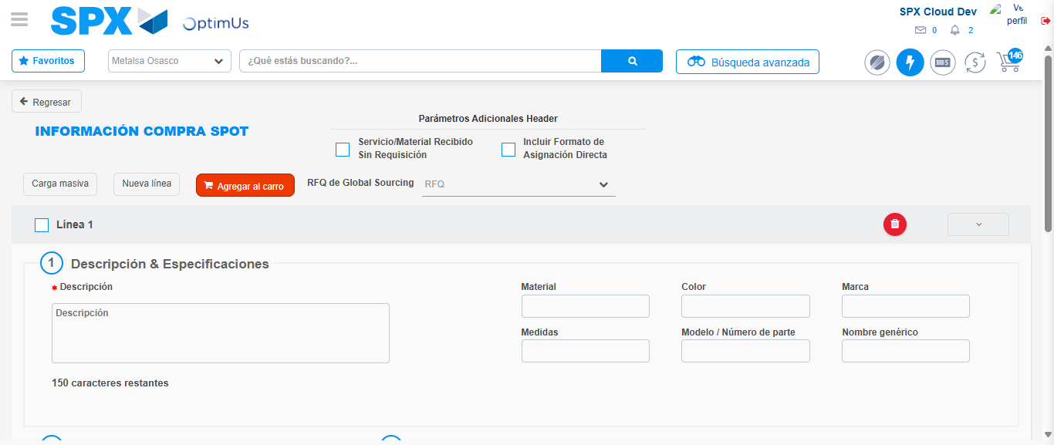Image file-name: QC_Testing-tc001_SPX_Dev5_Crear_Requisicion_Spot_Tipo_Cobro_CC-1782255622181

Step 7 - Return to Main Page SPX : Return to Main Page SPX
Image file-name: QC_Testing-tc001_SPX_Dev5_Crear_Requisicion_Spot_Tipo_Cobro_CC-1782255590665

Image file-name: QC_Testing-tc001_SPX_Dev5_Crear_Requisicion_Spot_Tipo_Cobro_CC-1782255593450

Image file-name: QC_Testing-tc001_SPX_Dev5_Crear_Requisicion_Spot_Tipo_Cobro_CC-1782255600749

Image file-name: QC_Testing-tc001_SPX_Dev5_Crear_Requisicion_Spot_Tipo_Cobro_CC-1782255624452

Image file-name: QC_Testing-tc001_SPX_Dev5_Crear_Requisicion_Spot_Tipo_Cobro_CC-1782255624657

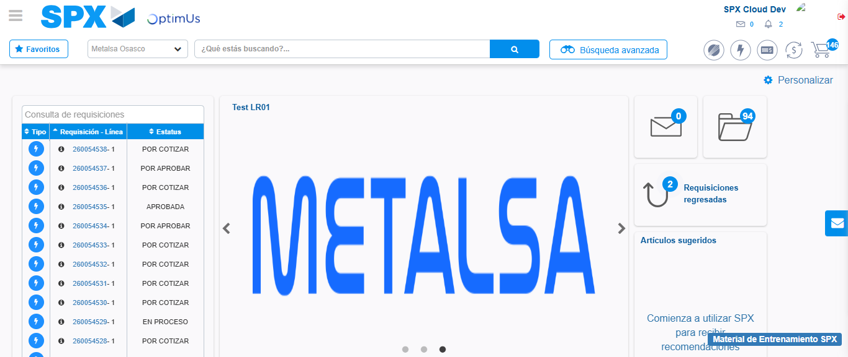Image file-name: QC_Testing-tc001_SPX_Dev5_Crear_Requisicion_Spot_Tipo_Cobro_CC-1782255646195

Step 8 - Log Out : Log Out SPX
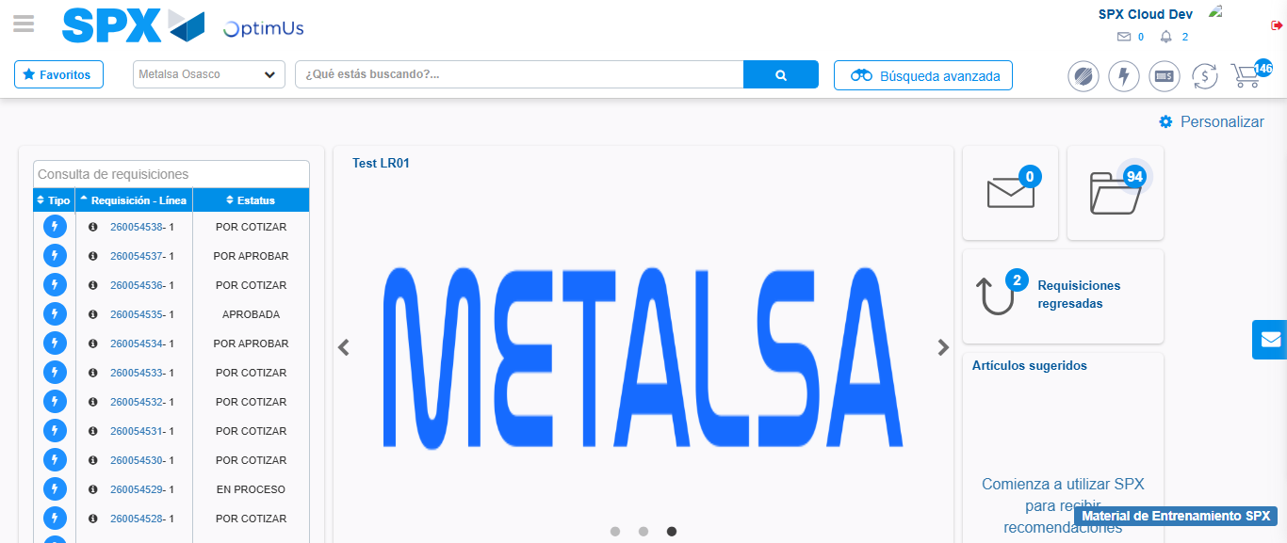Image file-name: QC_Testing-tc001_SPX_Dev5_Crear_Requisicion_Spot_Tipo_Cobro_CC-1782255646578

